PEACE Program Home Package

Dear family,
Firstly, I would like to validate that this is a very uncertain time for everyone right now and things are changing and developing extremely quickly.

If you are currently staying home, here are some resources to keep up with supporting your kiddo(s) and some fun family ideas!!!

Online Resources:
Scholastic.ca — Along with age appropriate information on Covid19, Scholastic has great activities and at-home teaching tools to keep your children entertained and learning!
GoNoodIe.com — A FREE treasure trove of silly dances, fun songs and calming yoga and breathing activities. You can either sign up on their website or search them on YouTube.
Books on YouTube — While our library is still open, if you are staying home and running out of fun books to read as a family, try searching them on YouTube! Some of my favorites are
“The Colour Monster” - by Anna Llenas - https://www.v outube.com/watch?v=lh0iu80u04Y "The Way I Feel" - by Janan Cain - https://was voutube. com/watch?v=ITPUxVQ6UIk

Some A†-Home Ac†ivi†ies:
Attached are some activities to stay on top of helping your family identify their feelings and express them in appropriate ways:
- I feel…
- Feelings cards
- Worry Box
- Coping Skills Fortune Teller
- Progressive Muscle Relaxation for kids
- Indoor Scavenger Hunt
- If I were a Super Hero
I will be checking in weekly via phone, but if you have any questions, concerns or your child wants to speak over the phone, don’t hesitate to call or email me at:
Tel:
Email:
Take care and stay healthy!!

I Feel:

Happy | Mad | Sad | Glad
Worried | Excited | Bored | Scared
Annoyed | Upset | Sick | Nervous

I feel this way because...

This is what I did about it...

Something else I could have done is...

Ask for help | Take deep breaths | Walk away | Do something else
Tell am adult | Talk to a friend | Have alone time | Ask for a hug

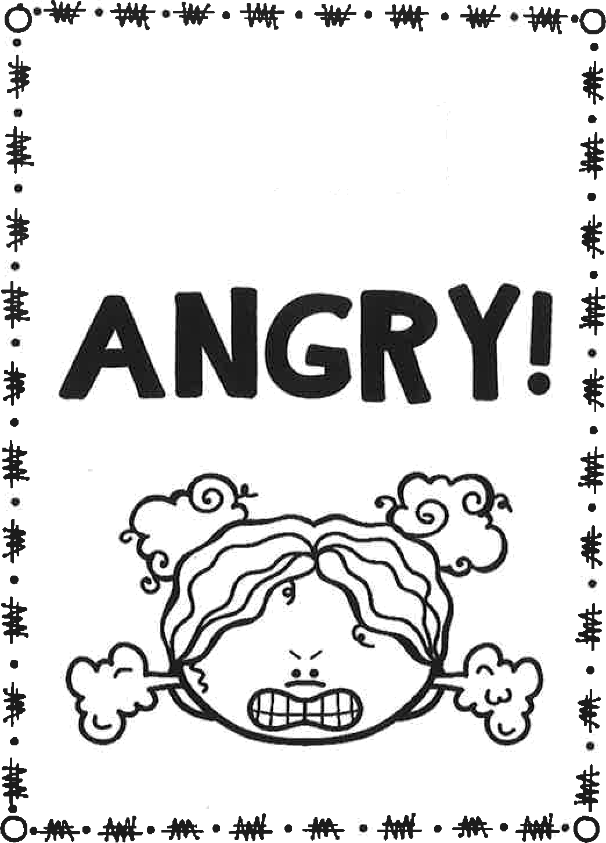
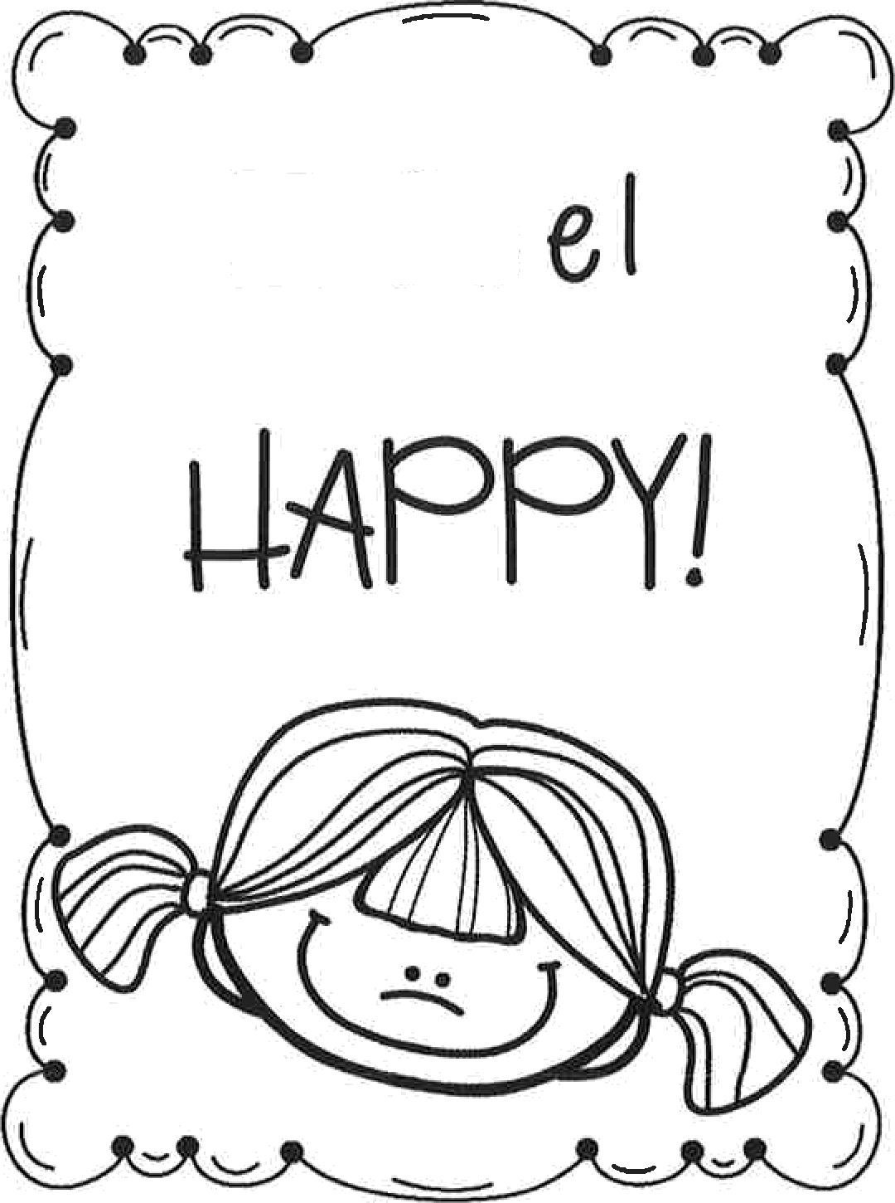
i i
i i i

i i i

i i
i i i i
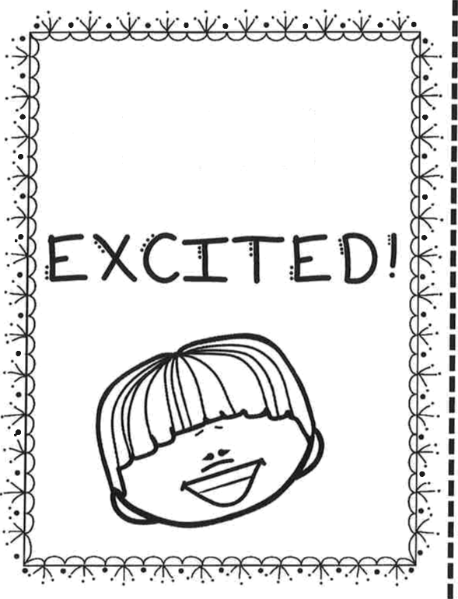
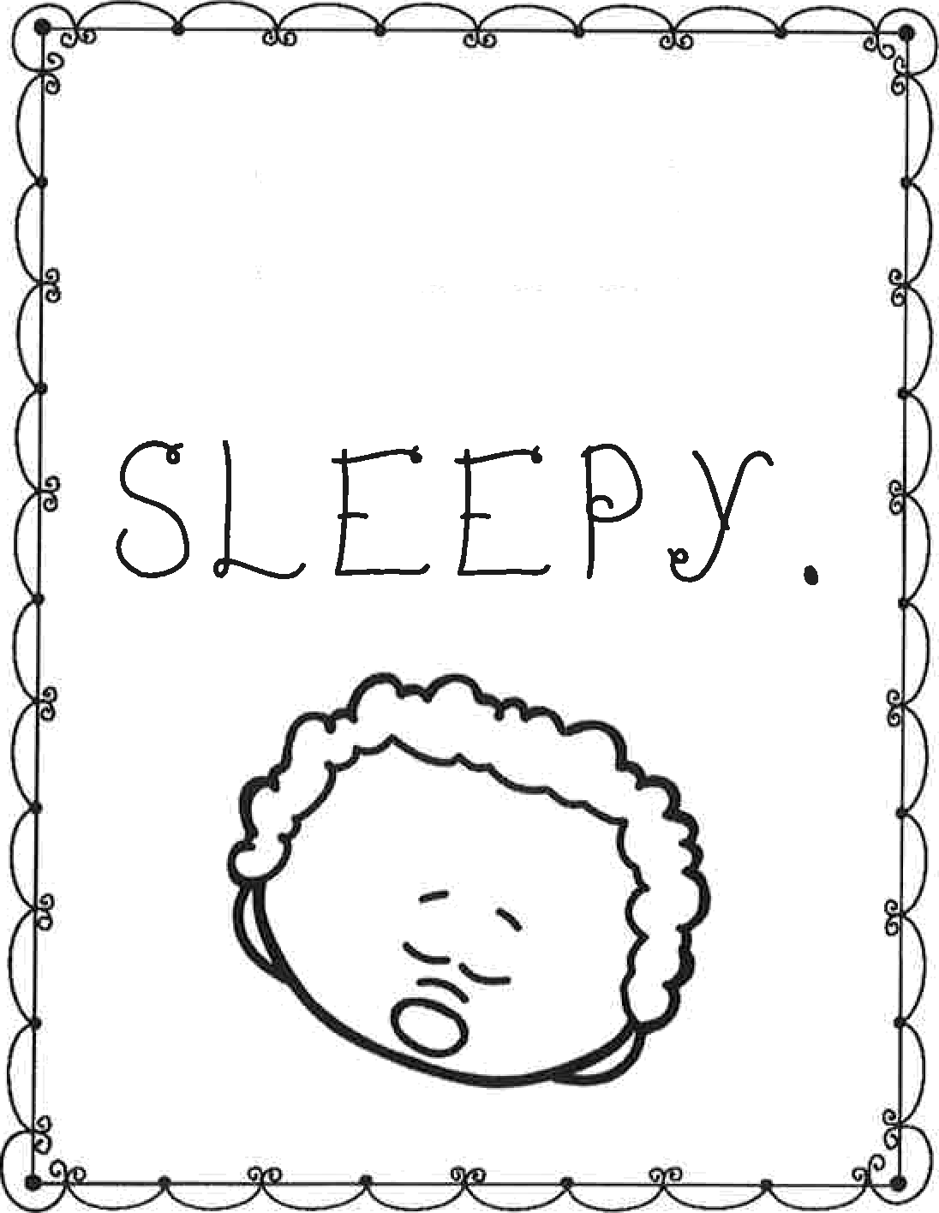

i i i
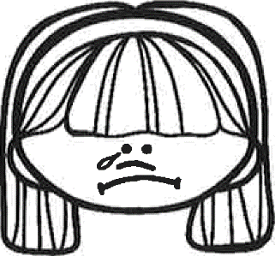
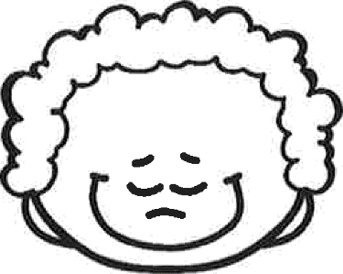
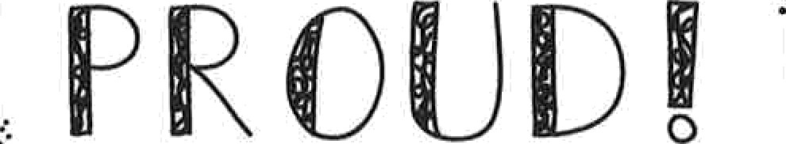
i ”-

1 0 y 0
i

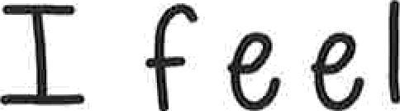
i i
i i i
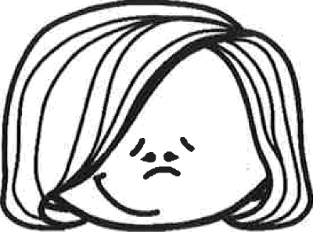
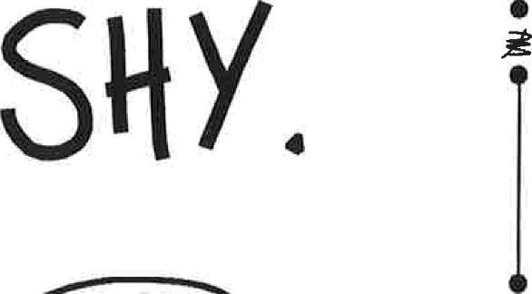
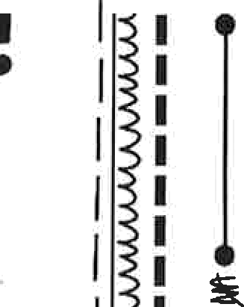
I i
I
i

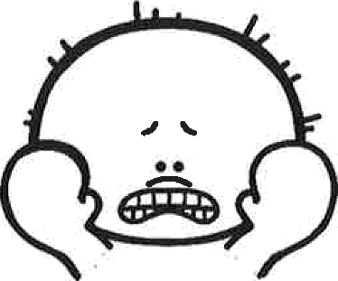
I i
i
I !
i

I i

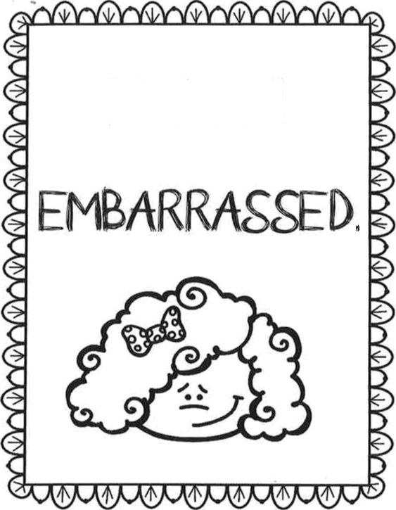
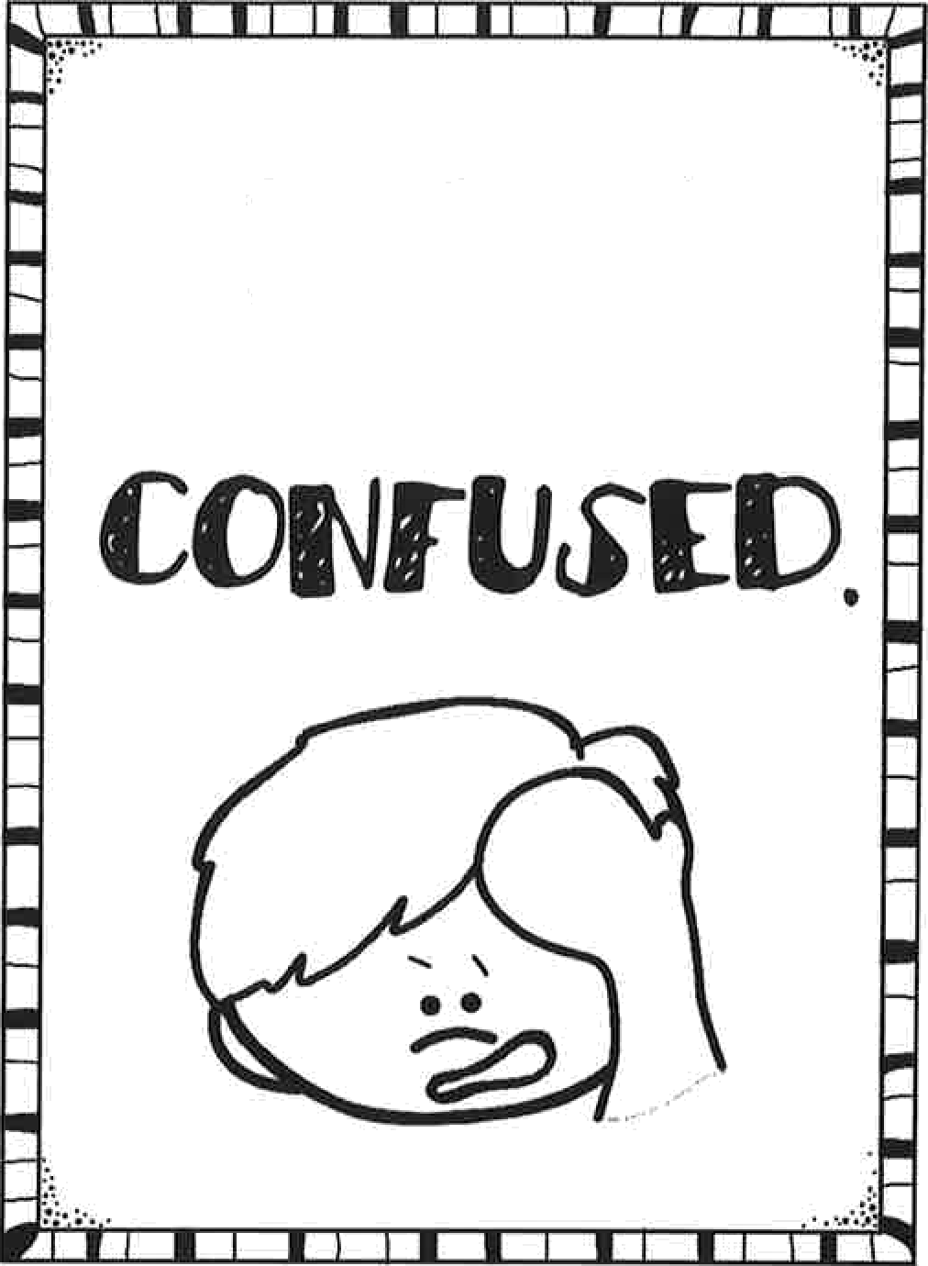
i i
I
i i

i i i i

I
i
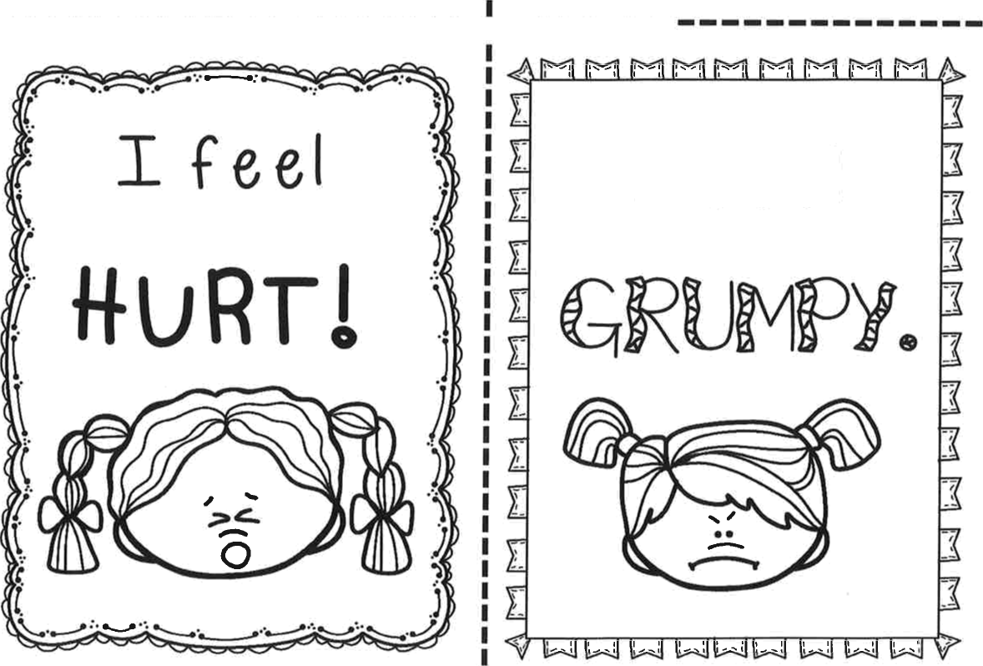

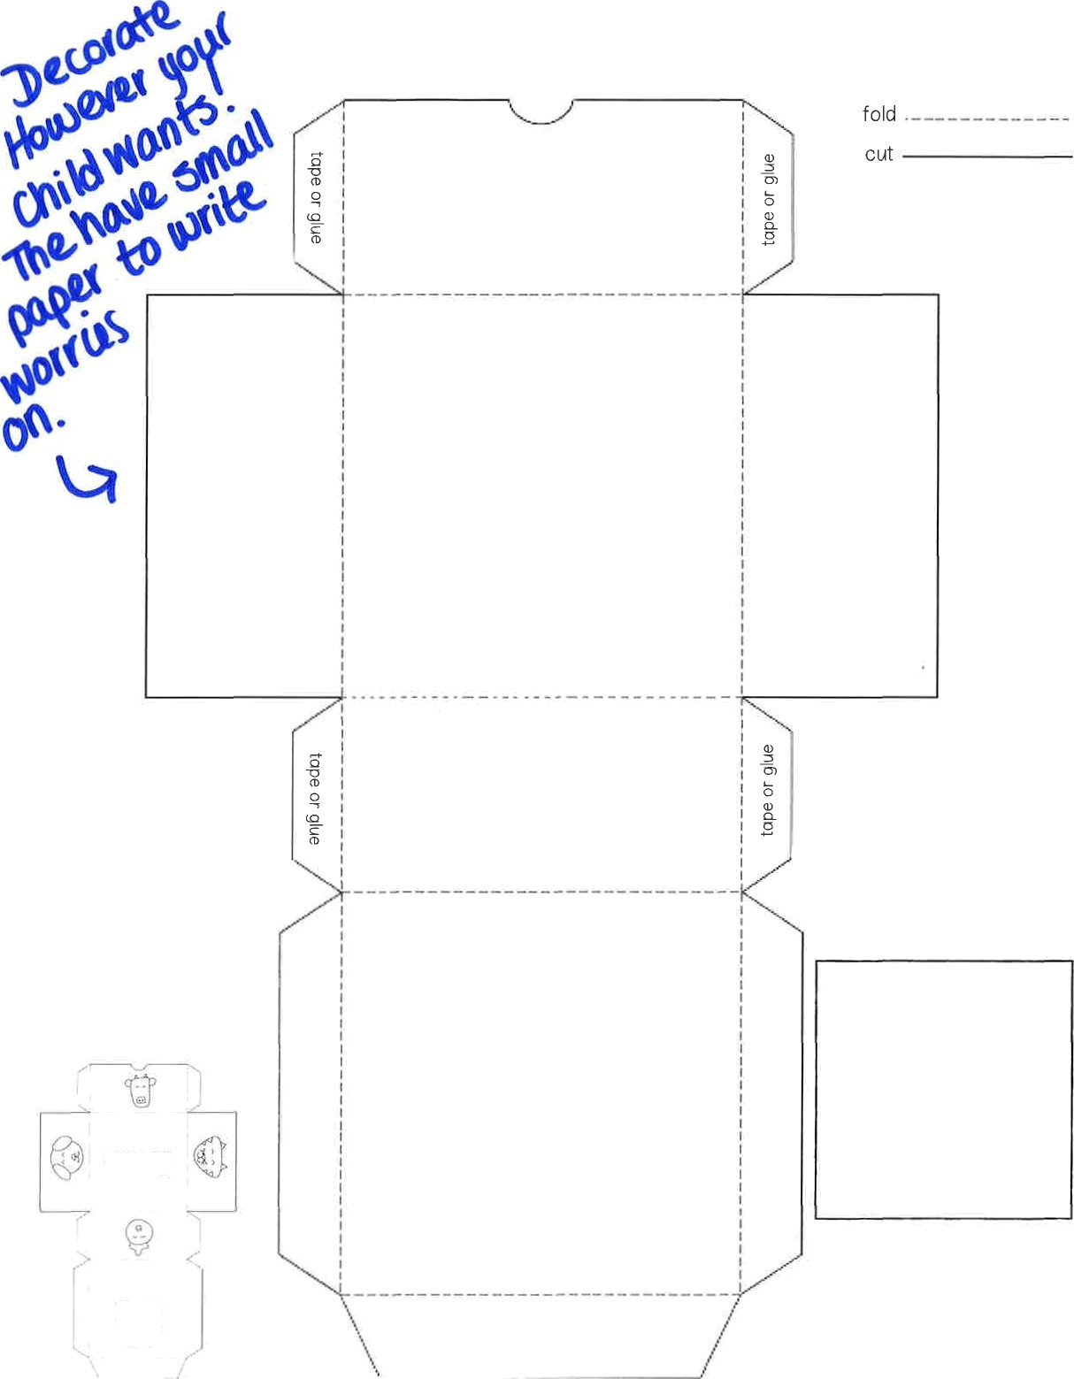

message insert

Worries are like visitors that sometimes come your way. Draw or write about what's bothering you and then tuck those worries away.
Inside this box, your worry visitors can rest and stay. Take a few deep breaths, saying goodbye for now and move on forward to create a great day.

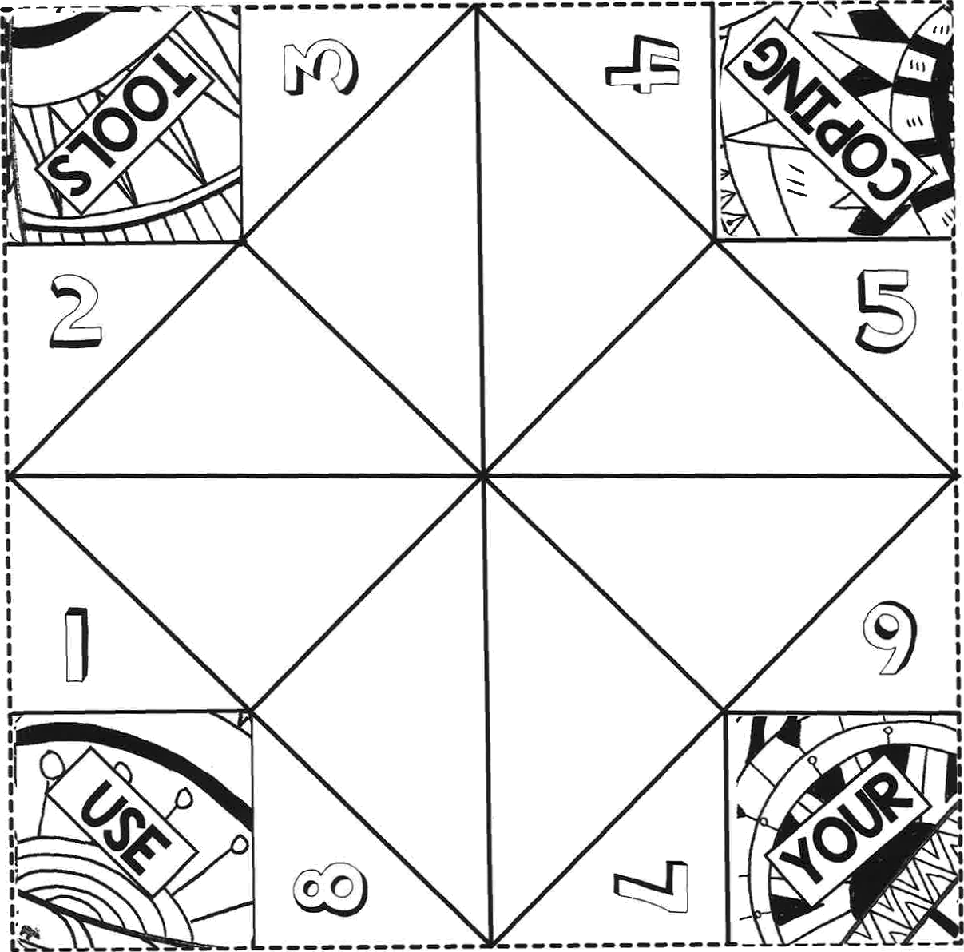
- Cut along all four sides of the fortune Seller's perimeter.

- Turn the printed side face down.
- Fold the square diagonal in half. Unfold. Repeat on other side. Unfold. This step marks the center.

- Fold the corners of

center. This creates a smaller square.

- Flip fortune Seller over. Repeat step 4, folding the corners of the square to the center. This creates an ever smaller new square, with the numbers showing.

- Fold this square in half, so that words now show. Unfold. Now fold the other side in half. This makes it easier to pinch and pull during game time.

- Place both thumbs and index fingers into the corner pockets.

- Have Fun!

Script for Progressive Muscle Relaxation for Kids
Tense your toes by wiggling them...like they are stuck in sand. 1...2...3...4...Relax and take a deep breath in and out. | 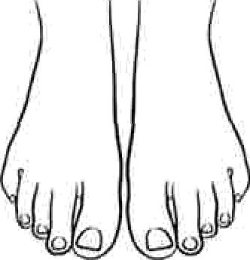
Tense your Stomach ...and imagine that an elephant was going to step on your stomach.  1...2...3...4...Relax and take a deep breath in and out | 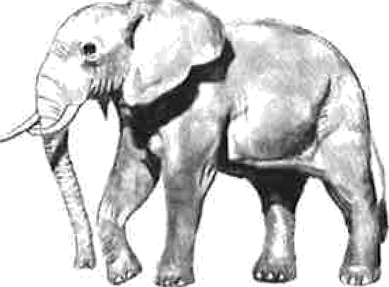
Tense your hands by making fists...like you’re trying to squeeze all the juice out of a lemon.  1...2...3...4...Relax and take a deep breath in and out. | 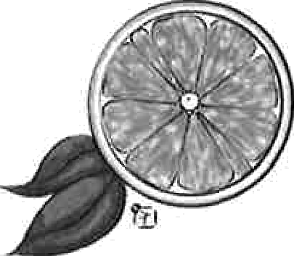
Tense your arms...like you’re showing off your muscles.
1...2...3...4...Relax and take a deep
breath in and out.
Tense your Shoulders by pulling them up...and imagine that you’re a turtle going into its shell.  1...2...3...4...Relax and take a deep breath in and out. | 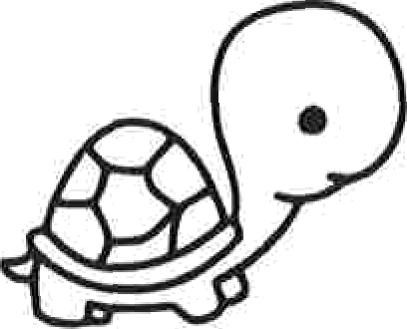
Tense your face by scrunching it up as much as you can.
1...2...3...4...Relax and take a deep breath in and out.

The INDOOR Scavenger HUNT!!!

- Something Round

- Something made of Plastic

- Something Red

- Something made of Cloth

- Something that starts with the letter H

- Something old

- Something smaller than a paperclip

- Something with numbers displayed on it excluding a clock or watch

- Something taller than you

- Something you can play with

- Something used on a holiday

- Something you can throw away

- Something you can only use outdoors

- Something you can only use indoors

- Something only a grown up would us
IF I WERE A SUPERHERO…

THIS IS HOW I WOULD LOOK.
I WOULD CHOOSE TO HAVE THE FOLLOWING ABILITY:

(choose 1)

ABILITY TO BECOME INVISIBLE
- ABILITY TO FLY

ABILITY TO READ MINDS

ABILITY TO SEE THROUGH WALLS
- ABILITY TO MOVE THINGS WITH MY MIND
- ABILITY TO TRAVEL THROUGH TIME SUPER-HUMAN STRENGTH

THIS IS WHAT I WOULD DO WITH MY SPECIAL ABILITY:

