What Difference Can the BELIEVE Project Make in Your School and Community?
What is the BELIEVE project all about?
Since 2004, 86 PEACE Programs formerly the Children Who Witness Abuse (CWWA) Programs have been partnering with educators of grades K – 12 in schools in their community to increase awareness about domestic violence and the impact domestic violence has on children and youth. Increasingly, PEACE Programs are being invited to classrooms and faced with questions while providing education on domestic violence, to respond to current experiences of sexual violence happening to girls in BC classrooms.
The BELIEVE project is an extension of the Violence Is Preventable program. The BELIEVE project provides children and youth with school-based support and education around issues of sexual violence including healthy relationships, consent, harassment, technology misuse and resources. The BELIEVE project educates not only children and youth but also educators about how to respond to sexual violence, and prevent it from happening in our BC communities.
Why The BELIEVE Project will benefit your students and community?
- Currently there is no provincial program that responds to sexual violence in K-12 BC Schools.
- Statistics show that up to 50 percent of sexual assaults are committed against girls under 16, and it is estimated that 150 million girls under the age of 18 suffered from some form of sexual violence in 2002 alone.
- Stats also tell us that perpetrators tend to be young. We know that interventions need to start early. The BELIEVE project is a sexual violence prevention program.
- The BELIEVE project directly aligns with the new provincial physical and health education core competencies within the new curriculum for grades 6-8.
Services offered by the BELIEVE Project:
- Sexual Violence Prevention Presentations: Designed for classrooms (Grade 6-8) for children and youth to learn about sexual violence, how to recognize unhealthy relationships, warning signs of sexual violence and harassment, what consent is, how to be safe when communicating over text messages/sexting/texting.

For more information about the BELIEVE project or to book your presentation please contact:

CWWA Counsellors Name:

Agency

Phone Number:

Email:

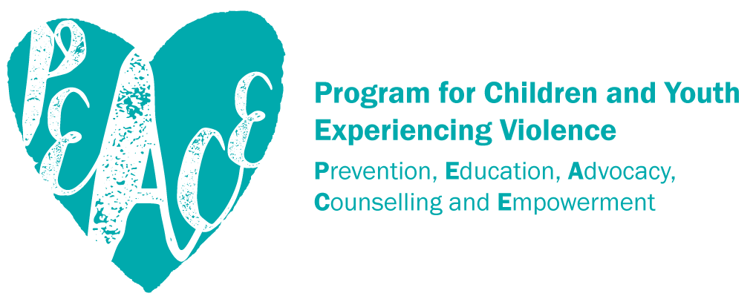
www.bcsth.ca

UNFPA, 2003. UNFPA and Young People; Imagine 2003. UNFPA, New York
WHO, cited in General Assembly.2006, Report of the Independent Expert for the United Nations Study on Violence against Children. United Nations, Geneva (p.10)
McInturff, Kate, “Canada’s Sexual Assault Problem” Retrieved December 6, 2016. http://behindthenumbers.ca/2016/12/05/canadas-sexual-assault-problem/

