What to do when someone you know needs help…
It can be very difficult watching a friend or loved one be in an abusive relationship. It can leave you feeling scared and unsure of how to help them. It is up to the person experience experiencing the abuse, as to whether or not they leave the relationship. Nobody can decide for them. It is important to know how you can help you friend/loved one stay safe.
Things to should consider:
If your friend/family member is undergoing the serious and painful effects of an abusive relationship, they may not be seeing things from the same point of view as you. They may have been told repeatedly that the abuse and violence is their fault, and start to believe it, and or even feel responsible. They may decide to stay in an abusive relationship, even if they are aware of what is happening. Your role as a friend, is to be there for them.
If they do decide to leave, they may be very upset and lonely. There may leave and go back to the abuser multiple times.
How to help?
- If you have safety concerns for a friend/loved one, let them know, and offer to help
- Be supportive
- Listen patiently
- Be non-judgmental
- Acknowledge their feelings and be respectful of their decisions
- Try and help your friend or family member recognize that the abuse is not “normal” and it is NOT their fault. Everyone deserves a happy, healthy, non-violent relationship
- Focus on your friend, or family member, not the abusive partner.
- Help your friend/loved one connect with local community resources that can help
- Help them develop a safety plan
- Come up with a safe word between the 2 of you
- Don’t contact the abuser, or post negative comments about them online. Put your friend/family member’s safety/wellbeing at the forefront. No matter how frustrated or upset you are, don’t take any rash decisions that may cause a negative consequence for them.
You Are Not Alone, there are people who can help:
Kids Help Phone: 1-800-668-6868
Victim Link: 1-800-563-0808
Crisis Line: 1-866-661-3311
www.YouthInBC.com
www.DomesticViolenceBC.ca

PEACE Program Counsellor:
Agency Name:
Email and Phone Number:
Adapted from: http://www.loveisrespect.org

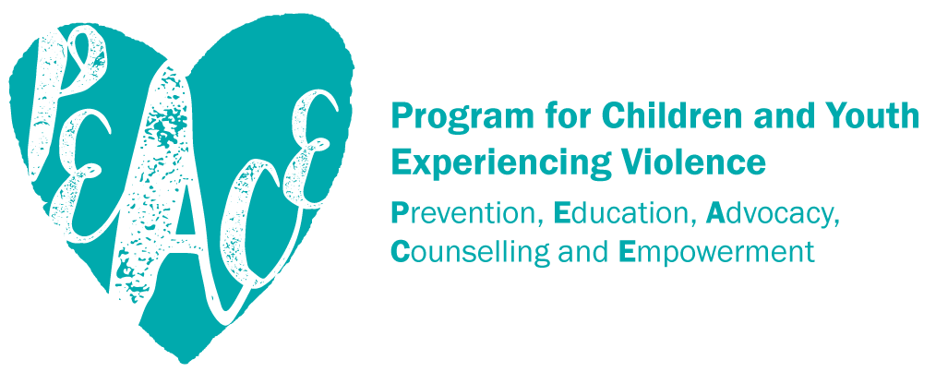
www.bcsth.ca

