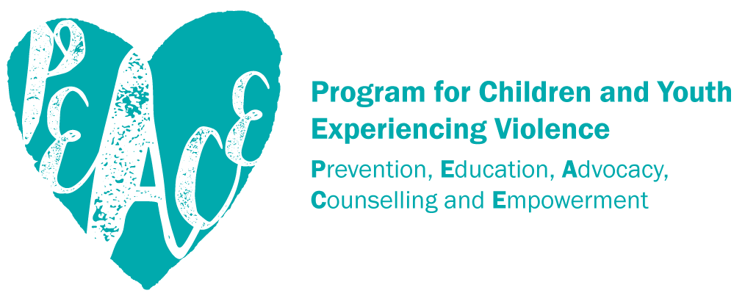

ORIENTATION BOOKLET FOR PARENTS AND CAREGIVERS

Phone Number:

[INSERT AGENCY LOGO]

Email:
Website:

PEACE Program Overview
The PEACE (Prevention, Education, Advocacy, Counselling and Empowerment) Program offers free, short-term psycho-educational support to children and youth in BC, aged 3-18, with experiences of violence in their homes.
The PEACE Program supports children and youth through individual and/or group support sessions, by providing a safe place where they can learn:
- that the violence is not their fault;
- that they are not alone; and
- that they have a right to be safe.
Where resources permit, PEACE Programs also offer information sharing and support to non-offending parents and caregivers.

Group Support
Groups are effective for children and youth as they learn they are not alone and can make connections with others who understand their experience. Groups are offered to children and youth of a similar age and developmental stage.

Individual Support
Individual support sessions can be provided when groups are not appropriate or available. Individual sessions can be tailored to meet the needs of the child/youth.
Topics covered during group and individual sessions may include:
- Building Rapport, Identity and Self-Esteem.
- Safety Planning.
- Understanding Violence Against Women and Healthy Relationships.
- Feelings and Communication.
- Anger.
- Boundaries and Self Care.

Parent and Caregiver Support
The most important factor in the wellness of children and youth is their caregiver’s wellness. Respecting and supporting caregivers is vital when supporting children and youth with experiences of violence. Our PEACE Program can provide caregivers with the following supports:
- List the supports for parents and caregivers offered by your PEACE Program here
- ….
- ….
- ….

What Happens Next?
- A PEACE Program counsellor will contact you when a space becomes available for your child in either group or individual sessions. If you have questions or concerns in the meantime, please contact us at: [insert contact details].
- Please let us know if there are any changes to your contact information while you are waiting for or receiving services. [Insert your programs policy regarding what you will do if you are unable to contact the family when a space becomes available].

Important Considerations about the PEACE Program
- The PEACE Program does not engage in legal matters with clients. We can provide resources and referrals for support in this area; however, we are not expert witnesses and cannot provide recommendations in court matters.
- The PEACE Program is short-term and offers psycho-educational support. Although it can have therapeutic benefits, it is not therapy. If the PEACE Program team assesses that your child’s needs require clinical therapeutic intervention, we will work with you to find more suitable support.

Confidentiality
Explain your agency’s Privacy and Confidentiality Policy here

Frequently Asked Questions
HOW LONG ARE COUNSELLING SESSIONS?
Individual counselling sessions are generally [enter time] in length. Your child’s counsellor may recommend shorter appointments for your child depending on their developmental stage. Please make every effort to be on time before and after scheduled appointments as a courtesy to other participants accessing the program.
HOW MANY COUNSELLING SESSIONS WILL MY CHILD RECEIVE?
The length of service to children and youth is generally between 8 to 12 sessions. At the start of counselling, the PEACE Program counsellor will complete an assessment with you and your child in order to set goals for service.
HOW MUCH DOES IT COST FOR MY CHILD TO PARTICIPATE IN THE PEACE PROGRAM?
There is no cost to participate in the PEACE Program.
WHAT IF WE NEED TO CANCEL A SCHEDULED APPOINTMENT?
If you know in advance that you/your child cannot attend a scheduled appointment, please call ASAP to cancel, as this may allow your child’s counsellor to see another program participant during that time. If possible, please give 24 hours’ notice of cancellation.
HOW DO WE CONNECT WITH OUR COUNSELLOR FOR OUR SESSION?
For safety reasons and in the event your child’s counsellor is not able to greet your child, parents/caregivers are asked to accompany children and youth before and after counselling appointments. Also, if possible, your child’s counsellor will want an opportunity to connect with you at some point during each scheduled appointment.
WHY DOES MY CHILD’S COUNSELLOR WANT TO MEET WITH ME?
Parents and caregivers are asked to meet individually with their child’s counsellor or arrange telephone appointments to discuss progress toward service goals and to allow the counsellor to provide relevant information about available supports.
Violence is a unilateral act - it occurs from one person towards others.
Violence is a choice.
When violence occurs, people resist in their own way.

Defining Violence and Abuse
Violence can take many different forms and includes:
- Emotional abuse;
- Psychological abuse;
- Verbal abuse;
- Financial abuse;
- Isolation;
- Intimidation;
- Physical abuse;
- Digital abuse;
- Sexual abuse;
- Spiritual abuse.

Possible Impacts of Experiencing Violence on Children and Youth
Children and youth with experiences of violence respond in various different ways. They may feel responsible for the violence, or they may blame other factors for the violence, such as siblings, school, substances like alcohol, or their non-offending caregiver. They may not understand that the responsibility rests with the person who is committing the violence.
You may notice emotional and behavioural changes even after you and your child are safe. These changes are normal responses to experiencing violence.

Children and youth with experiences of violence may learn:
- violence is an appropriate way to problem solve;
- violence has a place in the family;
- violence is a way to maintain power and control;
- if violence is reported there are few, if any, consequences;
- victims of violence must tolerate this behaviour and may be to blame for it;
- gender roles associated with violence e.g., males as perpetrators/in control, females as victims/submissive ;
- it is possible to love and inflict pain at the same time;
- it is a good way to relieve stress;
- inequality in relationships is normal.
Violent behaviour is learned, and can be unlearned!

What You Can Do If Your Child Has Experienced Family Violence
- Spend extra time with children, making an extra effort to show children you love them.
- Encourage them to be open with you about their feelings and thoughts.
- Praise them for their successes, no matter how small or big.
- Provide babies and young children with the extra physical attention they may need, such as holding or comforting.
- Work on building or improving trust between you and your children.
- Reassure them that you will do your best to be there for them.
- Be clear on what they can expect from you, and at home. Having a routine is helpful: Mealtimes, bedtimes, wake-up times, homework, and self-care such as teeth cleaning and showering.
- Encourage positive behaviour by introducing consequences for negative behavior, such as time-outs and removal of privileges.
- Create household rules such as “no hitting.”
- Use non-violent methods of discipline, such as time-outs, star charts, and giving consequences that avoid exposing children to hurtful punishment.
- As older children also need guidance, come up with a check-in system, and a curfew for youth.
- Make sure children know that violence is NOT okay.
- Help create a safety plan.
- Have a safety plan for yourself.
- Try to be available for support, encouragement, and help with homework and school projects.
- If you are able to take them to parks, libraries, community centres, or museums, do so.
- Learn about what your child is interested in, and encourage this.
- When children are angry, calm yourself first if necessary e.g., take deep breaths; think calming thoughts; perhaps leave the room for a few minutes; and remind yourself, “They are just kids,” and, “They are not doing this to deliberately bug me.”
- Accept their feelings: Try saying, “You are really angry,” but tell them it is NOT okay to hit/swear at/be disrespectful to others.
- Set a good example and be respectful – remember that you are an important role model for your children.
- If your child continues to hit/swear, send them into another room to cool off. If you have concerns that they are so angry that they might hurt themselves or destroy property, ask them to sit quietly where you can see them. You may need to hold a younger child.
- When they are calm, problem-solve with them about other ways to handle the issue, such as teaching them to use “I” statements: “When you take my doll without permission, I feel angry/hurt/sad.”
- Teach them other ways to express anger: Exercise, talking, writing/drawing about their feelings, skipping, scribbling on paper then tearing it up.
Things that aren’t supportive:
- Don’t give mixed messages to children such as, “Do as I say, but not as I do.” Set a good example.
- Never hit the child as punishment. No hitting, shoving, or pushing.
- Don’t get angry and say things you don’t mean, such as, “You’re just like your father,” or, “I wish you’d never been born.”
What you can say to children:
- Violence is never OK.
- I’m sorry that you heard /saw/ are aware of it. It must have been very scary for you.
- You didn’t cause it; it’s not your fault.
- There was nothing you could do to stop it or prevent it.
- Tell me how you feel about it.
- No kid deserves to experience violence in their family.
- I will do my best to keep you safe.
- We need to talk about what to do to keep you safe if it happens again.
- I care about you. You are important.

BCSTH thanks the PEACE Programs at Ishtar Women’s Resource Society and Haven Society for sharing their caregiver orientation packages on which this template is based.
Adapted from BC Children’s Hospital. (2005). Helping My Child: A guide to supporting children exposed to domestic violence. Also available on page 264 of the PEACE Toolkit.

